This document will guide candidates on using the downloaded exam app from the specified site of the university.
Exam application will create secure environment in your system. For it to work properly, it is important to disable AntiVirus program.
Disabling the Antivirus
- AVG
- Avast
- Bitdefender
- Kaspersky
- Norton
- Quick Heal
- McAfee
- Trend Micro
- Avira
- ESET
- Seqrite
- Comodo
- Malwarebyte
- Webroot
- F-Secure
- BullGuard
- G Data

Step to follow:
- Download the Windows Zip from the specified location of the university at specific location on your system.
- Right click on the downloaded file -> extract file (You can choose any option)
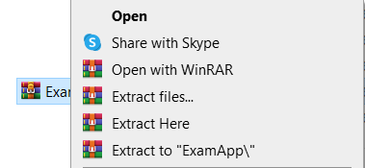

- Double click on extracted file, File name will be like University Name – Exam App.exe.

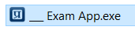

- Exam App will create the secure environment for the exam. It will look like below with the University logo in it.
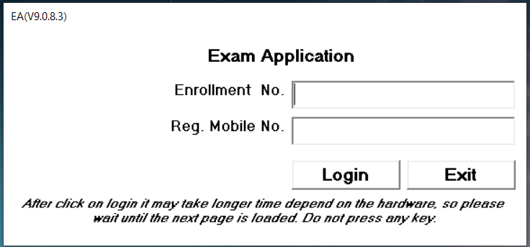

- Candidate needs to enter Enrolment No. & Reg. Mobile No. provided by the university. You may have to enter additional information if required. (Note: Due to any reason, If you want to close the exam, It is requested to click on EXIT button)

- Once you click on login, Examination screen will launch in secure environment asking for username, password and captcha.

DEVICE CHANGE  CAUTION | - If unable to start exam application, change your device.  - Candidate is allowed to change the device.
SUBMITTING PRE-TEST | Submitting final Pre-Test (during pre-test session time) from any 1 device is compulsory.
 | Laptop / Desktop
Pre-requisites | Windows
 | Version 7 or above
 | Chrome Latest
Permissions | - Allow all permissions (Microphone, Webcam and any other).  - Every time candidate needs to “Allow” the Webcam and Microphone permission at login page.  - If permission is denied exam application will not start.
Steps to install the exam application | - Download zip folder (.exe) from student portal. (You might have to unzip/extract the folder to get the .exe file)  - Check your chrome browser’s version. Should be latest.  - Disable anti-virus protection in your device.  - Check web-camera is working properly.  - Software name shouldn’t be changed. Otherwise candidate will not be able to open the application or login.  - Candidate will not able to do login if web-cam permission is declined by user’s end.  *Before re-downloading exam application, make sure to delete the previous .exe. Otherwise application will not start.
Opening the Exam Application | - Always use the original downloaded exam application.  - Do not use the shortcut from desktop to open the exam application.  - Open the exam application  - Enter your Enrollment No. and Registered Mobile Number.
If Unable to login  Or  Application does not start | - Check your Enrollment Number and Registered Mobile Number.  - Check your registered session time and date  - Check your CAPS lock for user name and password  - Check your username and password.  - Make sure to disable any antivirus / firewall  - Check your chrome version. It should be latest.  - Make sure you have given all the permissions to run the application.  - Your Windows version should be 7 or above.  - Press “Ctrl + Alt + Del for “End Task”. Close the process (.exe) and restart .exe / Restart your device.
Closing the application | Alt + F4  Press “Exit” button

