This document will guide candidates on using the downloaded mobile application (APK) from the specified site of the university.
Step to follow:
- Download the Mobile Application (.APK) from the specified location of the university website/dashboard/portal/erp.

- Allow app installation from “Unknown Source” after downloading app

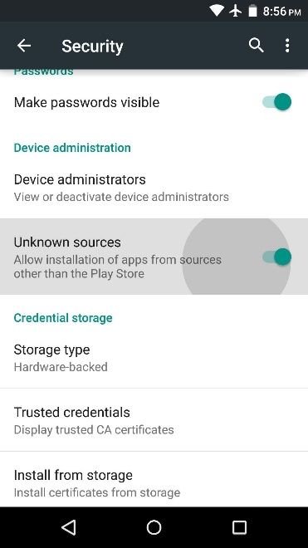
It would similar to below image:

* Enable Allow App Installations from Unknown Sources - Allow installation of apps from sources other than the Play Store. (This may vary from manufacturer to manufacturer).

- After downloaded install the application.
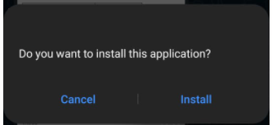

- Once the application is installed as per the image below. Open the application.

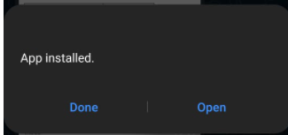

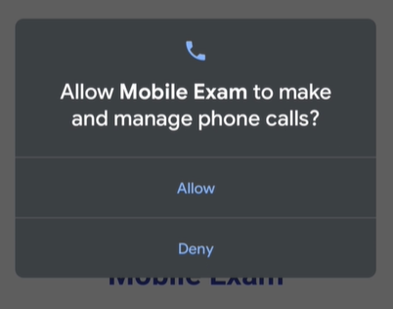
- Select ALLOW in the permission for required asks.
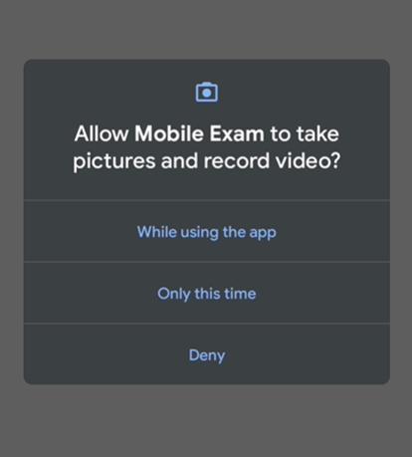

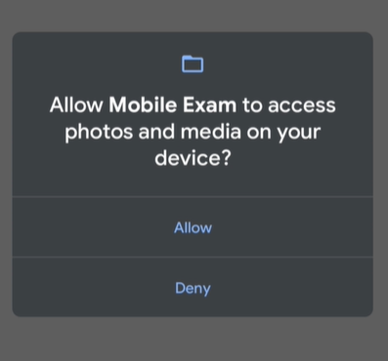
- Candidate needs to enter Enrolment No. & Reg. Mobile No. provided by the university. You can have additional or other fields as well.
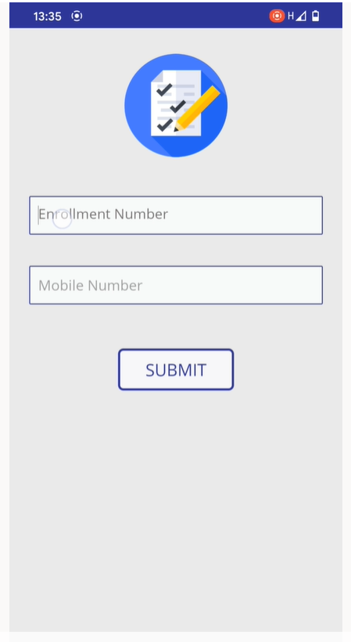

- Once you click on login, Examination screen will launch in secure environment asking for username and password.

DEVICE CHANGE  CAUTION | - If unable to start exam application, change your device.  - Candidate is allowed to change the device.
SUBMITTING PRE-TEST | Submitting final Pre-Test (during pre-test session time) from any 1 device is compulsory.
 | Mobile / Tablet
Pre-requisites | Android
 | Version 7.1.1 or above
 | Chrome Latest
Permissions | - Allow all permissions (Microphone, Webcam and any other).  - During time of installation candidate need to “Allow” all permission including Webcam and Microphone permission.  - If permission is denied exam application will not install or start.
Steps to install the exam application | - Download & install .apk from student portal.  - If application is not getting installed, then allow “Unknown Source” from mobile/tablet setting option.  - Disable anti-virus protection in your device.  - Check front (selfie camera) camera of mobile/tablet is working properly.  - Candidate should have to give all essential permission for application. Otherwise candidate wont be allowed to login.  - Candidate will not able to do login if web-cam permission is declined by user’s end.  * Enable Allow App Installations from Unknown Sources - Allow installation of apps from sources other than the Play Store. (This may vary from manufacturer to manufacturer).  **Before re-downloading exam application, make sure to delete the previous .exe. Otherwise application will not start.
Opening the Exam Application | - Open the exam application  - Enter your Enrollment No. and Registered Mobile Number.
If Unable to login  Or  Application does not start | - Check your Enrollment Number and Registered Mobile Number.  - Check your registered session time and date.  - Check your CAPS lock for user name and password  - Check your username and password.  - Make sure to disable any antivirus / firewall  - Check your chrome version. It should be latest.  - Make sure you have given all the permissions to run the application.  - Your Android version is 6 or above.
Closing the application | Home / Center button

